**Group members**

Dang Thi Thao My - 15905067

Bui Nguyen Thien Khanh - 15907679

Nguyen Anh Quan - 15905072

Le Huynh Anh Tuan - 1325907

**Supervisor:** MSc. Truong Phuoc Loc

**Product Owner:** Mr. To Hoa Duy Man

**Project Plan**

**Performance testing dashboard**

Version 1.4 – Released date: 01/09/2017

**Status**:

Approved by:

Released by: Capstone team (ETI1)

Internal

Document Revision History

|  |  |  |  |
| --- | --- | --- | --- |
| Version | Date | Changed by | Modifications |
| 1.0 | 10.10.2016 | Team | Initial version |
| 1.1 | 10.12.2016 | Team | Change: Communication, Collaboration, Configuration, Critical computer resource, Naming convention, Project timeline |
| 1.2 | 10.13.2016 | Team | Added: Term of Reference, Naming Convention, Change History Updated |
| 1.3 | 12.21.2016 | Team | Correct minor mistakes |
| 1.4 | 01.09.2017 | Team | Change front-end libraries |
|  |  |  |  |

List of Abbreviations

CCR **C**ritical **C**omputer **R**esources  
CI **C**onfiguration **I**tem  
CM **C**onfiguration **M**anagement  
HLD **H**igh **L**evel **D**esign

Contents

1. Introduction 1

1.1. Project OverView 1

1.2. Matrix Project 1

1.3. References 1

2. Roles and Responsibilities 2

2.1. Project Team 2

2.2. Customer 2

2.3. Sub-contract Management 2

2.4. Stakeholder Management 2

2.5. communication Management 3

3. Project Management 5

3.1. Assumptions, Dependencies, Constraints 5

3.2. Resources, Methods, Tools, and Techniques 6

3.2.1. Methodologies: 6

3.2.2. Technologies: 7

3.2.3. Tools and Software: 7

3.3. Risk and issue Management 8

3.3.1. Risk management 8

3.3.2. Issue management 8

3.4. Estimation 9

3.5. Project Schedule 9

3.5.1. Timeline summary 9

3.5.2. Milestones 9

3.5.3. Timeline for Deliverables 12

3.6. Critical Computer Resources 12

3.7. Functional Safety for ISO 26262 compliance 13

3.8. Decision Analysis and Resolution 13

3.9. Training 13

3.10. Project Management Reviews 13

3.11. Project Closure 13

3.11.1. Project closure procedure 13

3.11.2. Project Closure Form 14

4. Engineering 15

4.1. Engineering Lifecycle 15

4.1.1. Definition of Done (DOD) 15

5. Quality Assurance 16

5.1. QA activities 16

5.2. Quality Gates 16

5.3. Usage of lessons learnt, reuse, sprint retrospective meeting outcome 16

5.4. Process Tailoring 16

5.5. Metrics 17

5.5.1. Goal setting and control metrics 17

5.5.2. Plan to achieve the identified quality and process performance objectives 17

5.6. Product quality characteristics 17

5.7. Documentation and Records collection, maintenance, and retention 17

5.8. Backup and Recovery Plan 17

5.8.1. Backup 17

5.8.2. Recovery 17

5.9. Anti-virus Policy 17

6. Configuration Management 18

6.1. Introduction 18

6.1.1. Strategy for Configuration Management 18

6.2. Configuration Management Organization 18

6.2.1. CM Responsibilities 18

6.2.2. Baseline and List of Configuration Items 18

6.3. Storing and Retrieving Configuration Items 19

6.4. Naming Convention 19

6.5. Change Management 19

6.5.1. Change management procedure 19

6.6. Version Management 19

6.7. Interface Control 20

6.8. Configuration Status Accounting 20

6.9. Configuration Audits 20

6.10. Additional V & V tasks 20

7. Information Security Aspects in the Project 21

8. PP Maintenance 22

# Introduction

## Project OverView

Existing in Robert Bosch Engineering and Business Solutions Co. Ltd is a desktop testing application that is used only in local network to manually input and export reports for analysis and testing services. With the extension of demand, the RBVH/ETI1 department raises an idea of creating alternative application that can serve BOSCH and customers outside of the company as well as solving inconvenient issues from the existing application. Therefore, to realize their innovation, the ETI1 wants to make an alternative performance testing dashboard that run on website.

The project objectives will fix the manual setting and report problems from the desktop application and allow real-time graph and statistics for clients to track, view, analyze the performance testing live. The system will be more accurate than the desktop version because the report must be exported automatically with forms and correct figures through automated system. The automated system will automated running scripts and report exports, real-time comparisons, etc. which help to reduce testing time and efficient, convenient to work with this dashboard.

The project will make good use of Jmeter core and plugins to meet up the functionalities of LoadRunner and eliminate the budget spending on licensing. Hence, the product could be customized by BOSCH tester’s requirements for further upgrades and give our team an opportunity to become a future performance testing service provider if the product gain popularity and efficiency.

## Matrix Project

N/A

## References

|  |  |  |  |  |  |
| --- | --- | --- | --- | --- | --- |
| **REFERENCES** | | | | | |
| No. | Title | Version | Author | Date | Source |
| 1 | SRS | 1.0 | Scrum Team | 10.17.2016 | Docupedia |
| 2 | Project Charter | 1.0 | Scrum Team | 10.17.2016 | Docupedia |
| 3 | Minutes of Meeting | 1.0 | Scrum Team |  | Docupedia |
| 4 | Risk Management | 1.3 | Scrum Team | 10.11.2016 | Docupedia |
| 5 | Change Request Handling Log | 1.0 | Scrum Team | 1.5.2017 | Docupedia |
| 6 | Issue Log | 1.0 | Scrum Team | 1.5.2017 | Docupedia |

# Roles and Responsibilities

## Project Team

|  |  |  |  |
| --- | --- | --- | --- |
| Role | Responsibilities | Person in charge | Contact |
| Product Owner | * Provide vision for the team * Represent the users of the system. * Manage stakeholders and their requirements * Prioritize work for the team * Own and maintain the product backlog * Set the acceptance criteria | To Hoa Duy Man | Bosch internal emails |
| Scrum Master | * Encourage face to face communication * Help the team reflect and review continuously * Resolve conflicts * Solve problems | Dang Thi Thao My |
| Development Team | * Be full-stack developers (Design UI/UX, front-end, back-end). * Prioritizing the sprint backlog. * Split a user story into tasks. * Complete tasks to achieve sprint goal. * Communicate the status of the work on a daily basis. | * Dang Thi Thao My |
| * Bui Nguyen Thien Khanh |
| * Le Huynh Anh Tuan |
| * Nguyen Anh Quan |

## Customer

Robert Bosch Engineering and Business Solution Viet Nam

Mr. **Nguyen Huu Khiem (RBVH/ETI1)**

Email: Khiem.NguyenHuu@vn.bosch.com

## Sub-contract Management

N/A

## Stakeholder Management

|  |  |
| --- | --- |
| Stakeholder | Responsibility |
| Mr. Nguyen Huu Khiem | Group Manager - RBVH/ETI1 |
| Mr. To Hoa Duy Man | Product Owner, Project Manager – RBVH/ETI14 |
| Associates of ETI14 | Product users |
| Dang Thi Thao My | Scrum master |
| Bui Nguyen Thien Khanh  Nguyen Anh Quan  Le Huynh Anh Tuan  Dang Thi Thao My | Development team |
| Mr. Duong Thanh Nhan | Java Mentor |
| Mr. Truong Phuoc Loc | School Supervisor |
| Mr. Lam Quang Vu | HCMUS Coordinator |
| Mr. Petteri Kaskenpaolo | AUT Coordinator |
| Mr. Duong Viet Quoc Hoang | R&D Advisor |

**RACIS CHART**

## communication Management

|  |  |  |  |  |
| --- | --- | --- | --- | --- |
| Communication Name | Audience | Description | Schedule | Outcome |
| Daily Meeting | * Scrum Member | Face to face meeting at RBVH office | Daily at 9 am | Paper note. |
| Validation Team Meeting | * Validation Team Member | Face to face meeting at RBVH office | Every Tuesday at 10 am | MoM |
| Sprint End Meeting | * Scrum member * Project Owner | Face to face meeting at RBVH office | Friday/ 2 weeks at 4:30 pm | MoM |
| Sprint Planning Meeting | * Scrum member | Face to face meeting at RBVH office | Monday/ 2 weeks at 10 am | MoM |
| Meeting with supervisor | * Scrum member * Supervisor | Face to face meeting at HCMUS | Every Thursday at 3 pm | MoM |
| Other Communications | * Any | Through Skype, Outlook, and face to face… |  | None |

|  |  |  |  |  |
| --- | --- | --- | --- | --- |
| Meeting | Attendees | Time | Duration | Purposes |
| Sprint Planning | Development Team, Scrum Master, Product Owner | Beginning of the sprint – Monday mornings at 9 A.M | 2 hours | * Prioritize the product backlog * Discuss the effort to complete. * Form the sprint backlog |
| Daily Scrum | Development Team, Scrum Master, Product Owner | Every working day morning at 9 A.M | Less than 15 minutes | * Each team member will tell: * What they did yesterday * What they will do today * What problem they met |
| Sprint Review | Development Team, Scrum Master, Product Owner | End of the sprint – Friday at 4 P.M | 30 minutes | * Development team show what was built. * Get feedback from Product Owner. * Keep quality of the project. |
| Sprint Retrospective | Development Team, Scrum Master, Product Owner | End of the sprint – Friday at 5 P.M | 60 minutes | * Development team reviews and reflect what they have done and how they did it. * Suggest constructive improvement. |
| Meeting with supervisor | Development Team, Scrum Master, Product Owner,  Supervisor | Face to face meeting – Thursday at 3 P.M (ITEC) | 60 minutes | Inform the supervisor on the status of the project  Discuss and ask for advice on any issues related to the project. |

All the meetings are conducted on Skype Business or Face-to-face meeting. Other type of meetings will be carried out when it is needed.

# Project Management

## Assumptions, Dependencies, Constraints

|  |  |  |  |
| --- | --- | --- | --- |
| Description of Assumption and Constraint | Impact  (Schedule, Quality, Cost) | Required By | Status  (if tracked using schedule, need not be filled) |
| Availability of the hardware for the resource. | Schedule | At least 1 week before sprint Start. | Continuous |
| Availability of the required software for the task execution. | Schedule | Before project start date | Continuous |
| The development Team is work as full-time intern in 9 month to complete the project | Schedule |  | Continuous |
| The development team is working full-time in Bosch Office and always keep contact with each other. | Schedule, Cost, Quality |  | Continuous |
| We have to work 40 hours per week and not more than 10 hours per day. | Schedule | Bosch Policy | Continuous |
| Have to take 2 half-day left at Wednesday and Thursday’s afternoons to participate class in university | Schedule, Quality | School reason | Continuous |
| Have to take some days off to participate class in University | Schedule, Quality | School reason | Continuous |
| Have to complete the project before 5 – 6 June, 2017 | Schedule | School reason | Continuous |

## Resources, Methods, Tools, and Techniques

|  |  |
| --- | --- |
| Project resources, methods, tools, and techniques | |
| **Methodologies** | |
| **- Process** | Agile |
| **- Team Management and Control** | Scrum |
| **Technologies** | |
| **Front-end** | |
| **- HTML5/CSS3 Framework** | Bootstrap 3 |
| **- JavaScript Framework** | Highcharts |
| **Back-end** | |
| **- Java Framework** | Spring / Hibernate |
| **- Security Features** | Spring Security |
| **- Web Services** | Spring Web-Service (Spring-WS) |
| **Tools and Software** | |
| **- Communication Tool** | Skype for Business |
| **- Collaboration Tool** | Team Foundation Server |
| **- Source Code Management Tool** | Team Foundation Server / Git |
| **- Document Version Control** | Bosch ILM |
| **- Development Environment** | Eclipse IDE |
| **- Designing** | Adobe Photoshop / InDesign |
| **- Office Tool** | Microsoft Office |

### Methodologies:

**Agile process** was recommended.

- Performance Testing Dashboard is a new large project and our team was gathered from university so the project’ scope must be adjusted continuously during the development time.

- The prototype can fast delivered to our client so by receiving instant feedbacks we can make the final product more accurate with high quality.

- Every stage will be observed by client so there will be no critical misunderstanding between our team and client.

- The document work will be reduced and team can focus more on the quality of the products.

- This process will require more connection and interaction between team members as well as remaining good relationship with our client.

**For Team Management and Control:** we will use Scrum with 2 weekly sprint. Beside the benefits inherence from agile process, Scrum will help the project:

- Scrum requires members to work physically together so our team will have more time understand and work well with each other’s. Moreover, as working full-time (40 hours/ week) then we don’t have to worry about showing evident of working hours per day for our proposal at school.

- Scrum require cross-functional and self-organizing team so during the process every members can learn lots of things.

### Technologies:

**Front-end side:**

Bootstrap will be our main frontend framework for HTML5/CSS3 to build Dashboard. According to Product Owner’s dashboard template, Bootstrap will be used by following main reasons:

- Open Source, Twitter Bootstrap is an open source framework with a large community and rapid growth.

- Compatible with most of modern internet browsers: Google Chrome, Firefox, Safari and IE 8 above.

- Bootstrap provide many basic CSS and JavaScript libraries inside which can be inherence and customized easily.

- Time saving.

AngularJs2 will be our main JavaScript framework to use in this project. According to Decision Analysis and Resolution (DAR report) that is attached, Bootstrap will be used by following main reasons:

- Familiar syntax, with the help of Typescript the coding will easier and faster.

- Better performance.

**Back-end side:**

**Development Language**: In this project we use Java language with Spring Framework. Spring is a Java framework with largest community in the world so we can research and learn easier. Moreover, Spring provide a strong MVC structure but able to combine with other new technologies like AngularJs2.

**Backend Security:** For software’s security we will use Spring Security to provide authentication, authorization as well as other security features.

**Web services:** For further implementation and compatible with other services we will use Spring-WS. Spring-WS is one of Spring modules that also support application security with WS-Security.

### Tools and Software:

**Communication Tool:** In this project, our company use Skype for Business due to ISO Standard. Hence, Skype for Business will be our team’s main tool to communicate in the office (beside direct communication) and at home. Skype for Business provides video and voice call that is very essential. Skype for Business also have cache memory to store send and receive documents.

**Collaboration Tool:** Team Foundation Server (TFS) is recommend which can be used not only for Collaboration management but also source code management. TFS provides many features to manage team member work, tasks, requirements, backlog…

**Source Code Management Tool:** Beside TFS we also use GIT to control our source code when not working in the office.

**Document Version Control:** We will use Bosch ILM to manage versions of all documents.

**Development Environment:** Eclipse IDE.

**Designing**: Adobe Photoshop, InDesign.

**Office tools:** Microsoft Office.

## Risk and issue Management

### Risk management

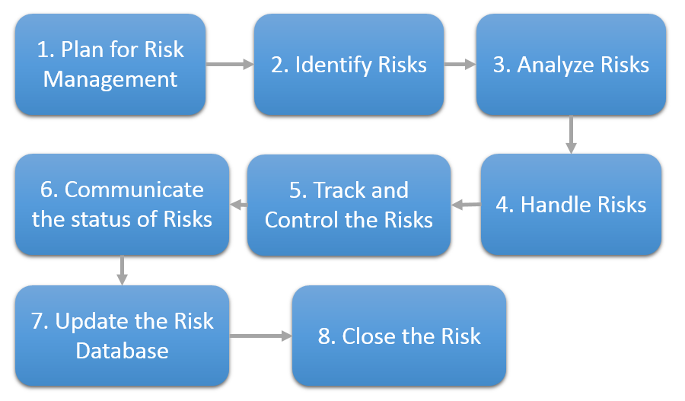

Figure 1 Risk managing procedure



### Issue management

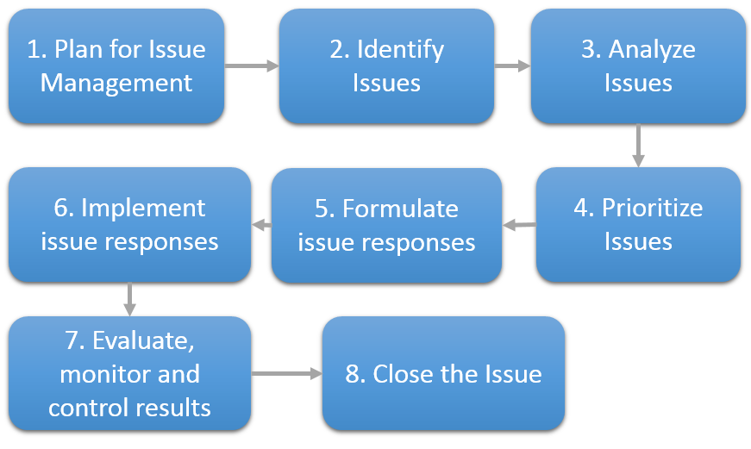

Figure 2 Issue managing procedure



## Estimation

The Project will using Planning Poker technique to estimate the size and effort of User story. This is a very commonly used methodology in agile software development. Planning Poker is usually played in Product Backlog Grooming:

* The Scrum Master will describe the user stories to be estimated
* Each participant is provided with a set of Planning Poker Cards. This card will having numbers in them typically following a Fibonacci sequence.
* Each participant will pick up a card from his deck which he thinks will best match the estimates.
* Once the time is up, participants will show the cards at the same time.
* Note down the point and go on until finish all for user stories.

## Project Schedule

### Timeline summary

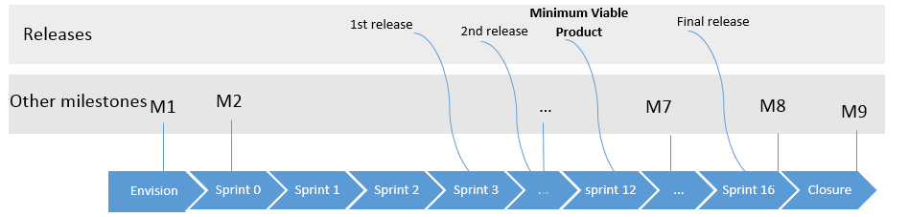

### Milestones

|  |  |  |
| --- | --- | --- |
| Key Milestone | Description | Planned date |
| M1 | Complete Gathering Requirements | 10/07/2016 |
| M2 | Proposal approved | 10/20/2016 |
| M3 | Complete Design | 10/24/2016 |
| M4 | Prototype approved | 10/26/2016 |
| M5 | Release 1 | 12/5/2016 |
| M6 | Release 2 | 1/16/2017 |
| M7 | MVP | 3/27/2017 |
| M8 | Final release | 6/5/2017 |
| M9 | Project end | 6/5/2017 |

**First sprint includes the below activities:**

* Write the proposal and get approval
* Become familiar the technology used for the project
* Develop prototype

**For other sprints:** client communication, planning, analysis, design, code, unit testing, and client evaluation.

The time goal of the project is to finish by the end of May 2017.

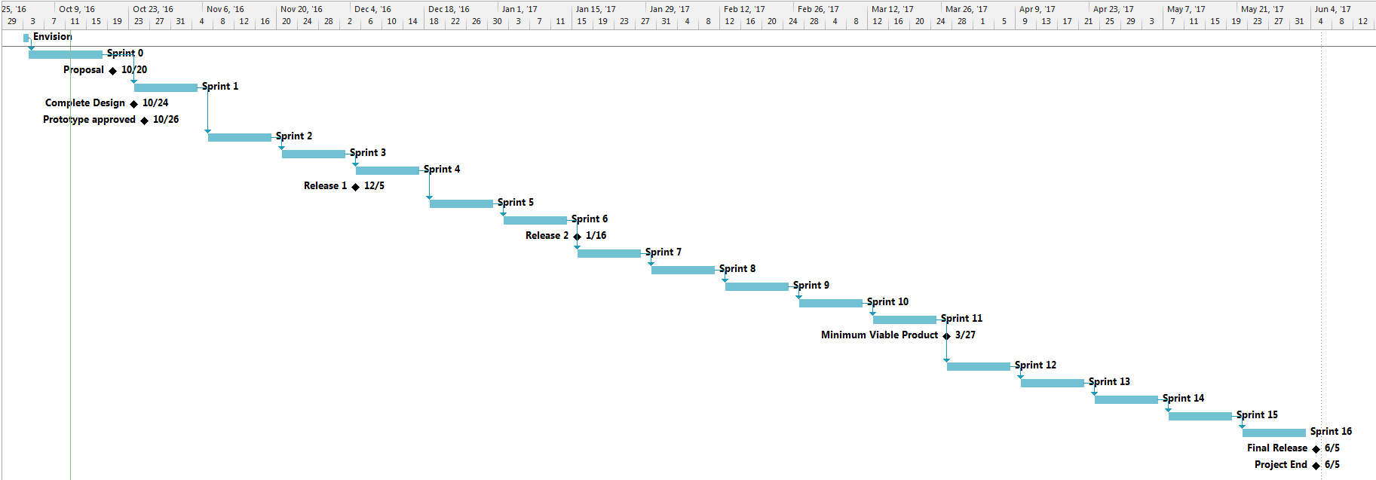

|  |  |  |
| --- | --- | --- |
| Sprint Name | Start date | End date |
| Sprint 0 | 10/10/2016 | 10/24/2016 |
| Sprint 1 | 10/24/2016 | 11/7/2016 |
| Sprint 2 | 11/7/2016 | 11/21/2016 |
| Sprint 3 | 11/21/2016 | 12/5/2016 |
| Sprint 4 | 12/5/2016 | 12/19/2016 |
| Sprint 5 | 12/19/2016 | 1/2/2017 |
| Sprint 6 | 1/2/2017 | 1/16/2017 |
| Sprint 7 | 1/16/2017 | 1/30/2017 |
| Sprint 8 | 1/30/2017 | 2/13/2017 |
| Sprint 9 | 2/13/2017 | 2/27/2017 |
| Sprint 10 | 2/27/2017 | 3/13/2017 |
| Sprint 11 | 3/13/2017 | 3/27/2017 |
| Sprint 12 | 3/27/2017 | 4/10/2017 |
| Sprint 13 | 4/10/2017 | 4/24/2017 |
| Sprint 14 | 4/24/2017 | 5/8/2017 |
| Sprint 15 | 5/8/2017 | 5/22/2017 |
| Sprint 16 | 5/22/2017 | 6/5/2017 |

### Timeline for Deliverables

|  |  |
| --- | --- |
| Deliverable | Time |
| Proposal | 10/12/2016 |
| SRS | 10/12/2016 |
| Project Plan | 10/22/2016 |
| Design | 10/24/2016 |
| Prototype | 10/24/2016 |
| Test plan | 4/21/2017 |
| Code | 5/26/2017 |
| Go live | 6/2/2017 |
| Technical Document | 6/1/2017 |
| Final Report | 6/1/2017 |
| Final Presentation | 6/5/2017 |

## Critical Computer Resources

The software will be developed in a Windows environment with Java being the primary language.

The Company RBVH has provided four Windows machines, software, and other facilities for use in the project. We also require a server for hosting the web and a system of computers to distribute performance test script.

## Functional Safety for ISO 26262 compliance

N/A

## Decision Analysis and Resolution

N/A

## Training

N/A

## Project Management Reviews

Conduct the Management Review of Project on an event driven basis based on the following triggers:

* Process Deviations
* Escalation by Project Manager
* Any other business issue, etc.

The following points can be considered while conducting the Management Review of Project:

* Highlights of project progress / status / future plans
* Business or Technical Issues (E.g. planning, resources, etc.)
* Top Risks
* Project Metrics (E.g. related to defect, productivity, schedule, effort, etc.)
* Customer Feedback
* Improvement actions (E.g. Preventive actions taken based on causal analysis / 8D, etc.)
* Best Practices to be shared with other projects in the department

## Project Closure

### Project closure procedure

The objective of this procedure is to ensure closure of projects in a systematic manner. It also ensures recording of project details, for future reference during maintenance and in planning for other projects.

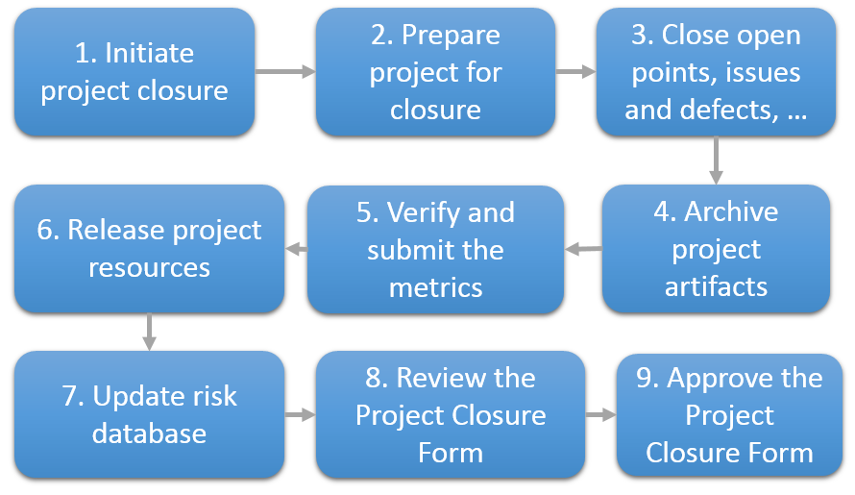

Figure 3 Project closure procedure

### Project Closure Form



# Engineering

## Engineering Lifecycle

### Definition of Done (DOD)

##### **Creation of the DOD**

At the beginning of each spring, the development team creates their “Definition of Done” for:

- User stories

- Sprints

- Releases

##### **Review of the DOD**

The team will review their DOD at the end of each sprint.

# Quality Assurance

## QA activities

The project team has to ensure the QA activities are performed properly.

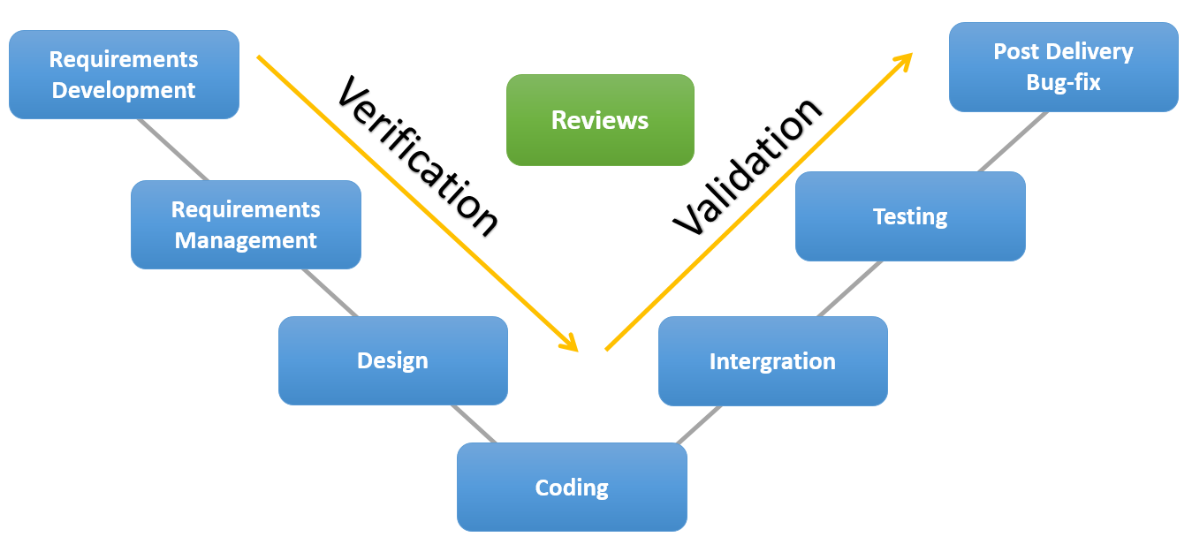

Figure 4 Quality Assurance activities

## Quality Gates

N/A

## Usage of lessons learnt, reuse, sprint retrospective meeting outcome

Whenever there is a lesson learned or a best practice, the team member recognized them should record and inform the project team in order to gain benefits from practicing them.

All the Sprint retrospective meeting outcomes are tracked on the Docupedia so that the whole team could view them.

## Process Tailoring

N/A

## Metrics

### Goal setting and control metrics

|  |  |  |  |  |  |
| --- | --- | --- | --- | --- | --- |
| Metrics | Objective | Unit | Applicable levels | Formula | Goal |
| %Doneness - Delivery | To improve planning and efficiency | Percentage | Sprint | %Doneness = Completed Story Points / Planned Story Points | Specify in each sprint |
| Velocity - Delivery | To aid in Sprint Planning  To improve planning and predictability | Number of Completed Story Points | Sprint | Velocity = Completed Story Points per Sprint | Specify in each sprint |

### Plan to achieve the identified quality and process performance objectives

Metrics will be tracking on the TFS, and the excel sheet base on the project goal. If any metrics lower than project baselines, a meeting will be conducted to identify the problem, identify the root cause and find preventative actions.

## Product quality characteristics

## Documentation and Records collection, maintenance, and retention

Documentation, Records collection, maintenance and retention of the documents shall be carried out as per the process defined in [**Document and Data Control**](http://sgpvm070:8080/pkit/go/pelement.do?id=23064&type=Activity&anon=1) Procedure of RBVH.

The identified list of documents and records of the project are maintained in Master-list.

The Master-list would be updated as and when the documents and records are created and approved.

The Master-list is reviewed and approved by the Project Manager.

## Backup and Recovery Plan

### Backup

The PCs and server backup follows the RBVH procedure.

### Recovery

The recovery process follows the RBVH procedure.

## Anti-virus Policy

Anti-Virus policy is as per Information Security and Privacy Rules for RBVH.

# Configuration Management

## Introduction

### Strategy for Configuration Management

Project artifacts is maintaining in RBVH CM tools LM.Inside Portal. AS project progress , it follow customer process , the subversion is maintained by one who responsible for requirement analysis , he/she will check out the required files from the tool and make modification due to required changes/updates and check in the file with update comments as the customer request new changes or requirements.

All project documents which are created by the SCRUM team will be stored in project folder on [ILM.Inside Portal](https://inside-ilm.bosch.com/irj/go/nui/sid/407749f1-cb0d-3410-2095-abdb8d8d5c42)

## Configuration Management Organization

For CM Tool our project will use ILM tool. ILM tool is Bosch’s product to manage version of documents.

### CM Responsibilities

|  |  |
| --- | --- |
| Task | Responsible |
| Configuration Management Set-up | Project Team |
| Identify, record and archive the Configuration Item’s | Project Team |
| Verify the completeness of the baseline | Scrum Master |

### Baseline and List of Configuration Items

Configuration Item list baseline and responsibility are shown below.

|  |  |  |  |
| --- | --- | --- | --- |
| No | Configuration Item | Trigger | Responsibility |
| 1. | Project Plan | After reviewed / approved | Product Owner |
| 2. | Requirement document | After reviewed / approved | Product Owner / Reviewer |
| 3. | Design document | After reviewed / approved | Product Owner / Reviewer |
| 4. | Prototype | After reviewed / approved | Product Owner / Reviewer |
| 5. | Source code | After development finish. | Product Owner |

## Storing and Retrieving Configuration Items

All of Configuration Item will be stored on Team Foundation Server, the access right will follow the company conventions and approved by Product Owner.

## Naming Convention

|  |  |  |
| --- | --- | --- |
| No | Configuration Item Type | Filename |
| 1. | Text Documents | * **Proposal**: Proposal_<ProjectName>_v<Number> * **SRS**: SRS_<ProjectName>_v<Number> * **Use** **cases**: UCase_<ProjectName>_v<Number> * **Time** **Tracking** **SpreadSheet**:   TimeTracking_<ProjectName>_v<Number>   * **Guidance**: Guide_<ProjectName>_v<Number> |
| 2. | Task | * **Task:** [Category] - TaskNameStartWithVerb. |
| 3. | Issue | * **Issue:** [Issue] - IssueName |

## Change Management

### Change management procedure

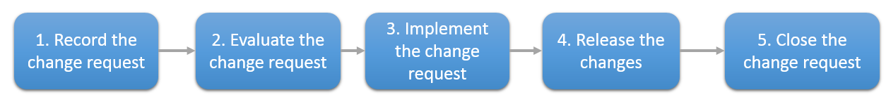

The Scrum Team will receive the change request from the customers, and these change request are new requirement to the project. The requirement changes when applicable will be recorded and clarify with customer. After finalize the change request, the team member will calculate the estimation and confirm with customer. After the estimation is confirmed, the team will implement the change request. No approval is needed for change request is needed. All evaluation about impact will be discussed and analyze with SCRUM team then report to customer and close the change.

## Version Management

**Document**

Version related information will be maintained using the header of the individual document, which in turn is based on the template released by RBVH. For minor modifications to the document, only minor version would be incremented. For new additions & major changes, major version would be incremented.

When there is need to keep old version of document for late comparison, the version number will be added to the document name. Ex: *Requirement_Specification_v1_0.docx*

**Source** code

For complete project, each release will be baseline in project folder under a folder with the name is version of release. Ex: *Release 1; Release 2* etc.

## Interface Control

N/A

## Configuration Status Accounting

N/A

## Configuration Audits

N/A

## Additional V & V tasks

N/A

# Information Security Aspects in the Project

In general, the project shall follow the Information Security practices as prescribed by C/ISP. Standards and Guidelines as well as those specifically defined for RBEI by the DSO department. Specifically, at the project level, with respect to “Information Systems Acquisition, Development and Maintenance” the practices as listed in the **“**[**Information Security Checklist for Projects**](http://sgpvm070:8080/pkit/go/pelement.do?id=16210&type=Artifact&anon=1)**”** shall be ensured.

The information security risks associated with the project, if any, shall be considered in the **“Information Security Risk Analysis”** of the department.

The **“**[**Information Security Checklist for Projects**](http://sgpvm070:8080/pkit/go/pelement.do?id=16210&type=Artifact&anon=1)**”** shall also form the basis for planning as well as all reviews in the project.

Several BOSCH Information Security practices listed on C/ISP System:

* Clean Desk Policy – Confidential information is not lying open.
* Lock workstation during short absence
* Password contains at least 10 characters and must be change each 6 months
* Email is used for business purposes
* Personal portable storage devices are not allowed to use at BOSCH
* Software download and installation by user are not allowed. Downloading or using cracked/key gen tool is strictly forbidden, or simply unacceptable
* Disconnect the Internet cable immediately if getting virus. Run OfficeScan to scan your Computer and contact Data Security Partner for support.
* Check for the safety link before access

# PP Maintenance

|  |  |
| --- | --- |
| Activities | Person in charge |
| Person responsible for PP Maintenance | Project Manager |
| Evaluation and approvals to changes in PP | Group Manager |
| Communication to changes in PP | Project Manager shall inform the development team. |

Updating of plan: Plan shall be updated at the end of each sprint and when significant changes are made.